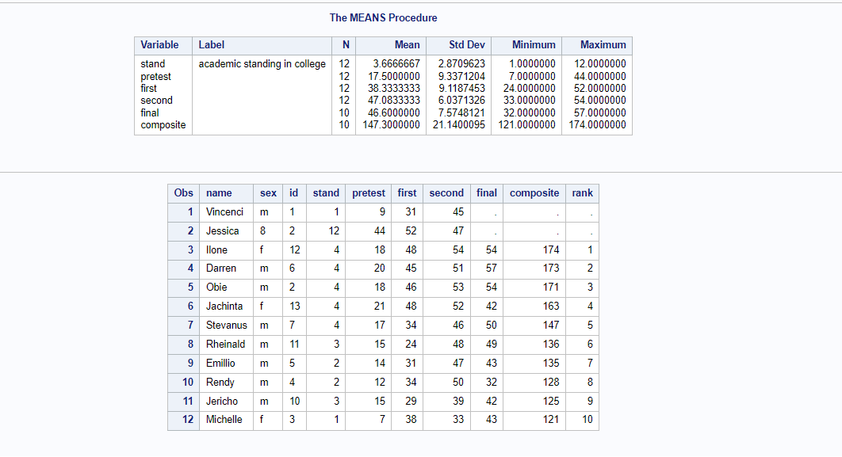

1. **What is the average score of the final variable?**

147.3000000

**2) Who is Number 1 in the class according to the ranked data?**

The Number 1 in class according to the ranked data is Ilone.

1. **What special note or warning is there in the Log window?**

